CHAPTER 1: DATABASES AND DATABASE USERS

Answer to Selected Questions:
1.1. Define the following terms: data, database, DBMS, database system, database catalog, program-data independence, user view, DBA, end user, canned transaction, deductive database system, persistent object, meta-data, and transaction-processing application.

1.2. What four main types of actions involve databases? Briefly discuss each.

Database Administration. Database Designing, Database Users, System Analysis and Application Programming
1.3. Discuss the main characteristics of the database approach and how it differs from traditional file systems.

Self-Describing nature of a database. Structure and constraints; information stored in catalogs called metadata
Insulation between programs and data and data abstraction
Support of multiple views of the data. A database typically has many users; each of whom may require different perspective are view of the database.
Sharing of Data and Multi-user Transaction Process: concurrency
1.4. What are the responsibilities of the DBA and the database designers?

DBA:
Build the physical design
technical responsibilities
Defence enforcement
Performance
Provide Access
Acquire resources: hardware, software
Backups
Recovery
Monitoring and Coordinating of use of db
Monitoring response time and security breaches
DB Designer:
data Identified
Appropriate Structure to store
Business needs
communicate architecture to business
ensure consistency across database
create and enforce database development standards and processes

1.5. What are the different types of database end users? Discuss the main activities of each.

Casual End Users: occasionally access the database, but they may need different information each time.
Naive or parametric end users: those type of end users makeup a sizable portion fo database end users. constant queries and updates
Sophisticated end users: engineers, scientists, businesss analysis and others. who thoroughly familiarize themselves with the facilities of dbms
Standalone Users: maintain personal databases by ready-mode program packages use gui. ex) tax program
1.6. Discuss the capabilities that should be provided by a DBMS.

Controlling Redundancy: normalization
Restricting unauthorized Access
Providing Persistent storage for program objects
Providing storage structures for efficient query processing
backup and recovery
Multiple User interfaces: query language, programming language interfaces (forms and command codes)
Representing Complex Relationships among Data
Enforcing Integrity Constraints
1.7. Discuss the differences between database systems and information retrieval
systems.

DB: data about single entity are stored in table
IR: Each programs has unique set of files
DB: Designed to meet the needs of multiple users & applications
IR: AT mercy of information department to write manipulation programs
DB: relatively complex to design, implement and maintain
IR: Simple to design and implement Single application
DB: process speed slow
IR: processing speed faster than other ways of storing data
DB: data independence.
IR : Data dependence.
DB Redundancy, Consistency standards of data quality. Improved sharing but can limit data sharing
DB: flexibility scalability not in IR
DB: reduce data redundancy.
IR redundancy is big problem
Answers to Selected Exercises
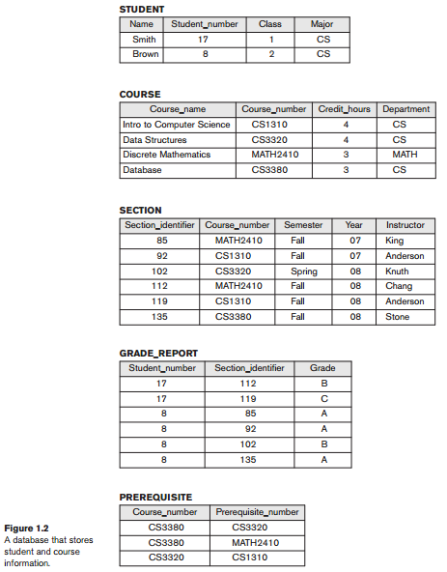
1.8 - Identify some informal queries and update operations that you would expect to apply to the database shown in Figure 1.2.

Answer:
(a) (Query) List the names of all students majoring in Computer Science.

(b) (Query) What are the prerequisites of the Database course?.

(c) (Query) Retrieve the transcript of Smith. This is a list of <CourseName,
SectionIdentifier, Semester, Year, Grade> for each course section that Smith has
completed.

(d) (Update) Insert a new student in the database whose Name=Jackson,
StudentNumber=23, Class=1 (freshman), and Major=MATH.

(e) (Update) Change the grade that Smith received in Intro to Computer Science section
119 to B.

1.9 - What is the difference between controlled and uncontrolled redundancy?

Answer:
Redundancy is when the same fact is stored multiple times in several places in a database. For example, in Figure 1.5(a) the fact that the name of the student with StudentNumber=8 is Brown is stored multiple times. Redundancy is controlled when the DBMS ensures that multiple copies of the same data are consistent; for example, if a new record with StudentNumber=8 is stored in the database of Figure 1.5(a), the DBMS will ensure that StudentName=Smith in that record. If the DBMS has no control over this, we have uncontrolled redundancy.

1.10 - Specify all the relationships among the records of the database shown in Figure 1.2.

Answer:
(a) Each SECTION record is related to a COURSE record.

(b) Each GRADE_REPORT record is related to one STUDENT record and one SECTION
record.

(c) Each PREREQUISITE record relates two COURSE records: one in the role of a course
and the other in the role of a prerequisite to that course.

1.11 - Give some additional views that may be needed by other user groups for the database shown in Figure 1.2.

Answer:
(a) A view that groups all the students who took each section and gives each student's
grade. This may be useful for printing the grade report for each section for the
university administration's use.

(b) A view that gives the number of courses taken and the GPA (grade point average) for
each student. This may be used to determine honors students.

1.12 – Cite some examples of integrity constraints that you think can apply to the database shown in Figure 1.2.

Answer:
We give a few constraints expressed in English. Following each constraint, we give its
type in the relational database terminology that will be covered in Chapter 6, for
reference purposes.

(a) The StudentNumber should be unique for each STUDENT record (key constraint).

(b) The CourseNumber should be unique for each COURSE record (key constraint).

(c) A value of CourseNumber in a SECTION record must also exist in some COURSE
record (referential integrity constraint).

(d) A value of StudentNumber in a GRADE_REPORT record must also exist in some
STUDENT record (referential integrity constraint).

(e) The value of Grade in a GRADE_REPORT record must be one of the values in the set
{A, B, C, D, F, I, U, S} (domain constraint).

(f) Every record in COURSE must have a value for CourseNumber (entity integrity
constraint).

(g) A STUDENT record cannot have a value of Class=2 (sophomore) unless the student
has completed a number of sections whose total course CreditHours is greater that 24
credits (general semantic integrity constraint).

1.13 - Give examples of systems in which it may make sense to use traditional file processing instead of a database approach.

Answer:
1. Small internal utility to locate files
2. Small single user application that does not require security (such as a customized calculator or a personal address and phone book)
3. Real-time navigation system (with heavy computation and very little data)
4. The students may think of others.

1.14 - Consider Figure 1.2.
a. If the name of the ‘CS’ (Computer Science) Department changes to ‘CSSE’ (Computer Science and Software Engineering) Department and the corresponding prefix for the course number also changes, identify the columns in the database that would need to be updated.
b. Can you restructure the columns in COURSE, SECTION, and PREREQUISITE tables so that only one column will need to be updated?

Answer:
a. The following columns will need to be updated.
Table | Column(s)
STUDENT | Major
COURSE | CourseNumber and Department
SECTION | CourseNumber
PREREQUISITE | CourseNumber and PrerequisiteNumber

b. You should split the following columns into two columns:
Table | Column | Split Columns
COURSE | CourseNumber | CourseDept and CourseNum
SECTION | CourseNumber | CourseDept and CourseNum
PREREQUISITE | CourseNumber | CourseDept and CourseNum
PREREQUISITE | PrerequisiteNumber | PreReqDept and PreReqNum

Note that in the COURSE table, the column CourseDept will not be needed after the above change, since it is redundant with the Department column.

